Determination of optical constants of ZnO growth by PECVD Method.

A. Aaaaaaaa Department of Physics, Faculty of Science, Firat University, Elazig 23169, Turkey

Plasma enhanced chemical vapor deposition (PECVD) is well-known for deposition of high quality nanostructures at low temperature. In this work, we have deposited the ZnO thin film on the Si substrate using PECVD without growing any seed layer. Zinc acetate is used as precursor material along with oxygen gas. The formation of ZnO film was confirmed with compositional analysis using energy dispersive x-ray spectroscopy (EDX). The ZnO growth in the preferential axis perpendicular to the substrate can be seen in 3D SEM image. The band gap of film is found to be 3.30 eV from the reflectance spectra. The optical parameter of the film deposited were calculated. Finally the dispersion behaviour of the film was investigated using the single oscillator model and was found that the ZnO film obeys the single oscillator model.

*Keywords:* Zinc oxide, Plasma, Chemical vapor deposition (CVD)

*Submission date:12 July 2016*

*Acceptance Date:20 October 2016*

*Corresponding authors*:[gggggggg@gmail.com](mailto:gggggggg@gmail.com)

**1. Introduction**

Zinc Oxide (ZnO) is a wide band gap material having direct band gap 3.37 eV, large exciton binding energy 60 meV, high transparency and high electron Hall mobility (200 cm2Vs-1) at room temperature [1]. These apparently contradictory properties, high transparency and conductivity, are being exploited for the several optoelectronic applications such as in solar cells [2], photo detectors [3], light emitting diodes [4] and thin film transistor [5]. The increasing pollution in the environment has attracted great efforts by the researchers to explore such materials which can eliminate the toxic materials from our environment and convert them into harmless elements. ZnO has excellent photo catalytic properties and good stability. Xia et al. [6] in his work has investigated the use of bio functional Fe3O4/ZnO nano composites as photocatalysts. On the other hand, ZnO being cheap, non-toxic and abundant in nature endows it great potential to replace the current toxic and expensive indium based transparent conducting oxide (TCO) thin films in solar cells, flat panel displays, sensors and numerous other applications.

There are several reports on the deposition of ZnO films using various technique such as sol-gel method, magnetron sputtering, spray payrolysis, chemical vapor deposition (CVD), molecular beam epitaxy (MBE), electrochemical deposition [10], pulse laser deposition (PLD) [7-12]. Chemical vapor deposition technique (CVD) is a versatile technique for fabrication of nanomaterial’s which provides control on several parameters such as temperature, pressure, gas flow rate, growth time, source substrate distance and source materials. The basic idea in CVD is to convert solid material into vapors, which are carried to substrate, where they chemically react on the substrate surface in presence of reactive gas. To date several different one dimensional ZnO nanostructures such as nanowires, nanotubes, nanobelts and nanorings has been reported [13-16]. We can obtain different shapes and size nano structures by controlling the above said growth factors. There are several investigation reports in which correlation of growth parameters of ZnO by CVD with different shape and size of nanostructured has been studied [17-19].

Whereas plasma enhanced chemical vapor deposition (PECVD) has advantage for low temperature deposition then normal CVD. Plasma is composed of various species like electrons, cation neutral radicals and atoms in excited state, which are readily reactive. The neutral species are in excess in concentration as compare to charged electrons and ions. Whereas the temperature of electron is much higher than the temperature of neutral radicals and other neutral species. Thus this non-equilibrium gives an opportunity, to utilize the electron impact reaction, resulting in enhance chemical reaction in the gas phase. These gas phase reaction helps in breaking and dislocation of many hard species like nitrogen molecules. Subsequently, large number of building units are formed that interact with the surface and develop the nanostructures [20-21]. Chang at el. Has reported that plasma treated oxygen has considerable effect on the ZnO surface layer [22] increasing the surface roughness of the buffer layer and improving the quality of ZnO nanostructures. Also, the oxygen ions created by the plasma increases the nucleation sites on the substrate for the formation of ZnO. In some studies a very thin seed layer of ZnO is deposited by spin coating on the Si surface to facilitate the nucleation of ZnO during the CVD process.

In this work, we have deposited ZnO film using the PECVD technique and we have determined the optical constant for the deposited film on the Si substrate without using any seed layer.

**2. Experimental details**

A p-type silicon polished on one side (250-micrometer thickness,<100> oriented, 1-10 Ω-cm) was used as substrate. Firstly, the silicon substrate was cleaned by RCA process. The MTI corporation (OTF-1200X-4CLV-PE) PECVD system was used to deposit ZnO film on the substrate. The radio frequency (RF, 3.15Mhz) operated power supply plasma generator with copper coil wounded around the 3.14 inch diameter quartz tube near the gas feed entrance creates the plasma inside tube. The zinc acetate dehydrate (Zn(CH3COO)2.2H2O) in pallet form was used as source for Zn. The vacuum was created in the glass tube with rotary pump to obtain 20 mtorr. The Si substrate was kept at distance of 5cm from the source downstream at the center of the tube. Then the furnace was heated till we reached fixed temperature 250°C and maintained it. The oxygen gas was introduced at the constant flow rate 10 SCCM and the pressure of inside the quart tube is raised to 240 mtorr. The deposition was carried for 30 min at the constant oxygen pressure and plasma power of 240 W. After the deposition process film was further annealed in the air at 450°C for crystallization in the furnace.

For the optoelectronics device application of ZnO thin films necessitate the better investigation of the optical constants of the films. The optical properties were measured by UV-3600 Shimadzu spectrophotometer. JEOL JSM-7001F scanning electron microscope (SEM) with energy dispersive X-ray spectroscopy were employed to study the morphology and structural characterization of the films.

**3. Results and discussion:**

The elemental composition analysis of ZnO thin film was done using energy dispersive X-ray (EDX) and result is shown in the Fig.1. The well-defined peaks in the EDX spectrum shows clearly the formation of ZnO. The only zinc and oxygen peaks shows that our film is composed of zinc and oxygen only. The peak around 2 Kev belongs to Si substrate and apart from that no other peaks observed in the spectrum belonging to any impurity.

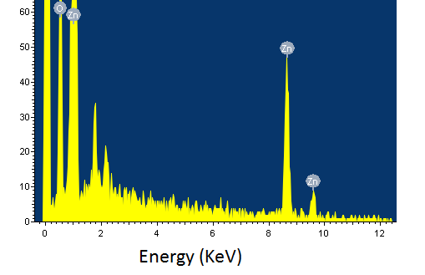

*Fig.1:**EDX analysis of ZnO thin film.*

The morphology of the ZnO film has been studied using field electron microscopy (FESEM). The 2D and 3D images of the ZnO nanostructured film has been shown in Fig.2. The average surface roughness of the thin film is found to be 1.513 nm. The image shows the homogeneous and well- developed ZnO grain structures with average size of 30nm on the substrate.

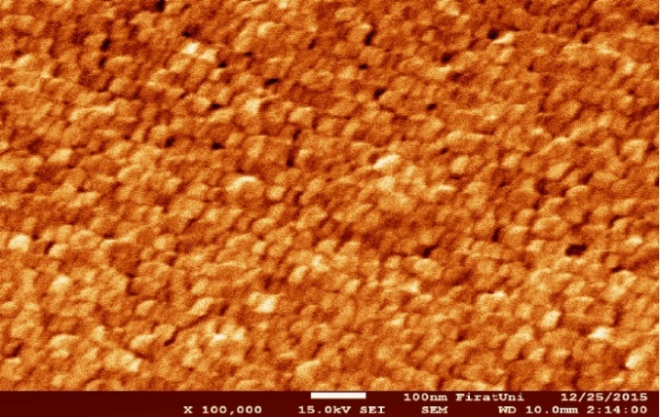

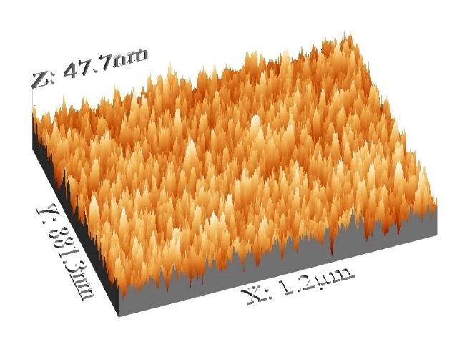

*Fig.2:**2D and 3D SEM images of PECVD deposited ZnO thin film.*

The 3D SEM micrograph clearly shows that the grains are growing preferentially perpendicular to the substrate. For the ZnO preferential growth in the c-axis occurs because of the surface free energy of this plane among the hexagonal crystallographic planes [23].

The spectral distribution of reflectance R(λ) at normal incident for all the films is shown in Fig.3.



*Fig.3:**Reflectance spectra for ZnO thin film.*

The reflectance spectra R(λ) shows the typical antireflection behavior of ZnO film. The normal reflectance for all the investigated film is less than 15% and it is also observed that the reflectance values of the films in visible region of solar spectrum changes and shows a peak around 410nm. This peak shows the band gap transition. The optical band gap, Eg, was determined using the Tauc relation for amorphous semiconductors [24].

 (1)

Where α is absorption constant, hυ is the photon energy and B is a constant. But in case of diffuse reflectance when the sample surface is rough some of the light penetrate inside the sample and undergoes combination of scattering and absorption inside the sample. Some of the radiation is reflected back towards the surface. This reflected radiation contains useful information due to higher order of interaction. The reflected radiation is called Kubelka-Munk (KM) reflectance and is defined by a function. The KM function F(R), can be used to approximate the optical absorbance of the sample from is reflectance and is given by [25].

 (2)

For the direct band gap, the plot between (F(R).hν)1/2 and photon energy (hν) has been shown in Fig.4. The band gap value can be determined by extrapolating the graph of the linear region of the plots to energy axis at (F(R).hν)1/2 = 0. The band gap energy is found to be 3.30 eV which is very close to the reported band gap value for ZnO thin film fabricated by sol gel method [26].



*Fig.4:**(F(R).hν)1/2 vs. photon energy (hν)**for ZnO thin film.*

The study of dispersion is crucial for the application of any material in the field of integrated optical devices and device design for optical communication and spectral dispersion. The refractive index of the film was determined by the following relation [27].



 (3)

Where K= αλ/4π is the extinction coefficient. The dependence of refractive index on the wave length is plotted in Fig. 5. The refractive index decreases with increasing the wavelength. The value of the refractive index is (n = 1.2 -2.0) in the visible range whereas generally the value of n for ZnO is about 2. The refractive indices shows a peak around wavelength λ = 400 nm which could be attributed to band gap interaction. In conclusion the refractive index shows a normal dispersion in visible wavelength region.



*Fig.5:**The refractive index n for ZnO thin film.*

This dispersion of refractive index has been analyzed using wemple and Didomenico (WDD) single oscillator model. This model describes the interband absorption edge of the material below the band gap corresponds to the electronic transition spectrum. The single oscillator model in terms of refractive index n, single oscillator energy Eo and dispersion energy Ed is expresses as [28].

 (4)

Where Eo and Ed are the single oscillator constants. The parameter Eo is an average band gap, the so called WDD band gap. Whereas Ed is oscillator strength and is related to interband optical transition. Eo and Ed are determined from the graph between (n2-1)-1 vs (hν)2 as shown in fig 6. The calculated values of Eo and Ed from the slop (EoEd)-1 and intercept (Eo/Ed) on the y-axis are given in table 1. The oscillator energy Eo is an average energy gap and in a close approximation with the optical band gap $E_{g}^{opt}$, in which, Eo ≈ 1 .5 $E_{g}^{WDD}$, as suggested by WDD model.

The refractive index dispersion curve show that the film obeys single oscillator model for ZnO. The values of Eo and Ed for the ZnO fabricated by PECVD are in close approximation with reported values in sol-gel derived ZnO thin film [29].



*Fig.6:**The refractive index n for ZnO thin film.*

**Table 1**: Optical parameters of the PECVD deposited ZnO.

|  |  |  |  |
| --- | --- | --- | --- |
| **Film** | ***Eg* (eV)** | ***Eo* (eV)** | ***Ed* (eV)** |
| ZnO | 3.30 | 5.06 | 24.1 |

**Conclusions**

It was demonstrate that highly good quality ZnO film is fabricated with preferential growth perpendicular to Si substrate. The compositional analysis of film was done using EDX. The band gap and other optical parameters were determined. The dispersion of refractive index was studies using single oscillator model. All the parameters are in well agreement with previously reported values.

**References:**

[1] S.J. Pearton, D.P. Norton, K. Ip, Y.W. Heo, T. Steiner, J. Vac. Sci. Technol. B, 22 (2004) 932–948.

[2] K. Mahmood, H.W. Kang, S.B. Park, H. J. Sung, Appl. Mater. Interfaces, 5 (2013) 3075−3084.

[3] J. Sun, Q. Dai, F. Liu, H. Huang, Z. Li, X. Zhang, Y. Wang, Sci. China. Phys. Mech. Astron., 54 (2011) 102–105.

[4] D. Hwang, O. Min-Suh, J. Lim S. Park, J. Phys. Appl. Phys., 40 (2007) 387–412.

[5] K.K. Banger, Y. Yamashita, K. Mori, R.L. Peterson, T. Leedham, J. Rickard, H.Sirringhaus, Nat. Mater., 10 (2011) 45.

[6] J. Xia, A. Wang, X. Liu, Z. Su, Appl. Surf. Sci., 257 (2011) 9724–9732.

[7] S. Ilican, Y. Caglar, M. Caglar, J. Optoelectron. Adv. Mater., 10 (2008) 2578–2583.

[8] W.Y. Zhang, D.K. He, Z.Z. Liu, L.J. Sun, Z.X. Fu, J. Optoelectron. Adv. Mater. Rapid Commun., 4 (11) (2010) 1651–1654.

[9] L.H. Van, M.H. Hong, J. Ding, J. Alloys Comp., 449 (1) (2008) 207–209.

[10] M.H. Aslan, A.Y. Oral, E. Mensur, A. Gul, E. Basaran, Solar Energy Mater. Solar Cells, 82 (2004) 543–552.

[11] O.A. Novodvorsky, L.S. Gorbatenko, V.Y. Panchenko, O.D. Khramova, Y.A. Cherebilo, C. Wenzel, J.W. Bartha, V.T. Bublik, K.D. Shcherbachev, Semiconductors, 43 (2009) 419–424.

[12] O.A. Novodvorsky, L.S. Gorbatenko, V.Y. Panchenko, O.D. Khramova, Y.A. Cherebilo, C. Wenzel, J.W. Bartha, V.T. Bublik, K.D. Shcherbachev, Semiconductors, 43 (2009) 419–424.

[13] T.J. Kuo, C.N. Lin, C.L. Kuo, M.H. Huang, Chem. Mater., 19 (2007) 5143.

[14] S.L. Mensah, V.K. Kayastha, I.N. Ivanov, D.B. Geohegan, Y.K. Yap, Appl. Phys. Lett., 90 (2007) 113108.

[15] J.H. Park, H.J. Choi, Y.J. Choi, S.H. Sohn, J.G. Park, J. Mater. Chem., 14 (2004) 35.

[16] W.L. Hughes, Z.L. Wang, Appl. Phys. Lett., 86 (2005) 043106.

[17] Y.J. Park, J.D. Lee, S.Y. Yun, H.J. Moon, T.B. Lee, S.S. Kim, J. Cryst. Growth, 276 (2005) 158.

[18] X. Liu, X. Wu, H. Cao, H.P.R. Chang, J. Appl. Phys., 95 (2004) 3141.

[19] J. Song, X. Wang, E. Riedo, Z.L. Wang, J. Phys. Chem. B., 109 (2005) 9869.

[20] K. Ostrikov and A. B. Murphy, J. Phys. D: Appl. Phys., 40 (2007) 2223.

[21] K. Ostrikov, Rev. Mod. Phys., 77 (2005) 489.

[22] J. Jang, H. Ryu, W. Lee, and J. Yun, J. Alloys Compd., 577 (2013) 395.

[23] Y. Kajikawa, J. Cryst. Growth, 289 (2006) 387-94.

[24] J. Tauc, A. Menth, J. Non-Cryst. Solids, 8 –10 (1972) 569.

[25] N. Chester, Optical Sensors and Microsystems, Kluwer Academic Publishers, 2007, pp. 160.

[26] M. caglar, S. Ilhan, Y. Caglar, F. Yakuphanoglu, App. Surf. Sci., 255 (2009) 4491–4496.